Schoology from a computer:
- Go to wcskids.net
- Find the link Parents/Students
- Scroll down to Schoology link
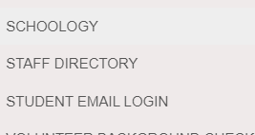
- Log in using your student ID@wcskids.net example 12345@wcskids.net
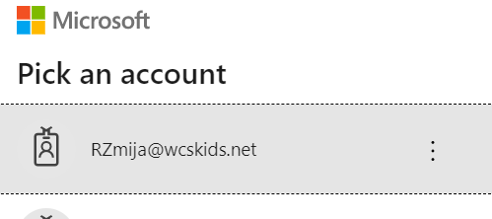
- Password is what you use to log onto a school computer.
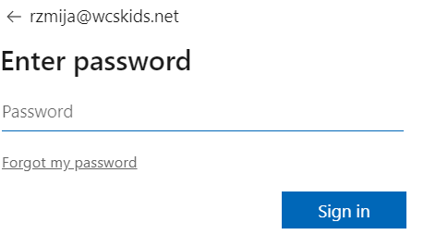
- All of your courses will be on the page.
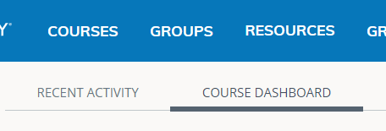
- Click on ELA class
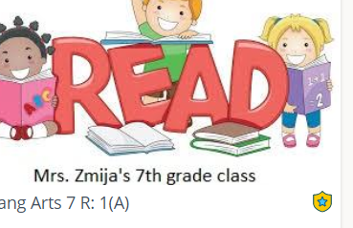
7th grade 6th hour 2nd & 4th hour

- Click on the Week for assignment.
- Click on the assignment and to add your writing to the assignment
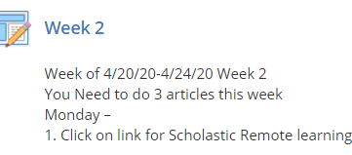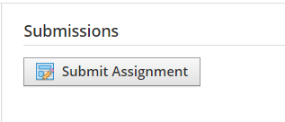
- You can either upload a picture or file. Or you can type your paragraph right there.
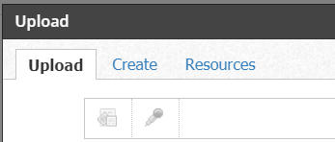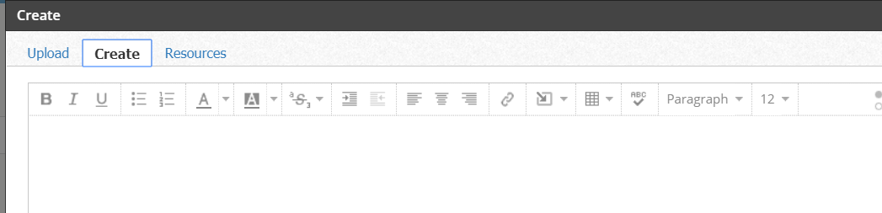

- You save the document and come back to every day until Friday and then hit Submit.
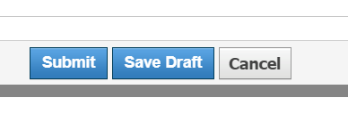
- You click on the link to the articles for the week.
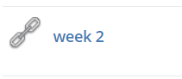
- The week on the website should be the same as the folder.
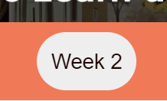

- Each day you are to choose 1 of the 4 articles to read.
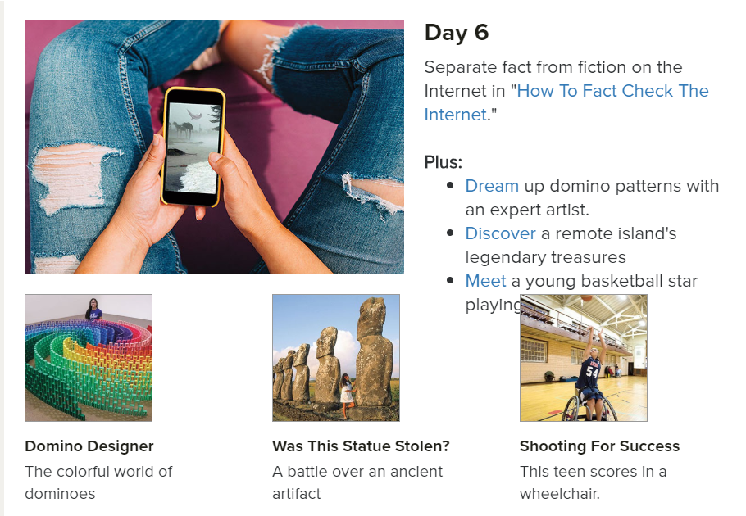

- After you read the entire article and watch any slides/videos, you’ll scroll to the bottom and find this box: Continue the Learning Journey
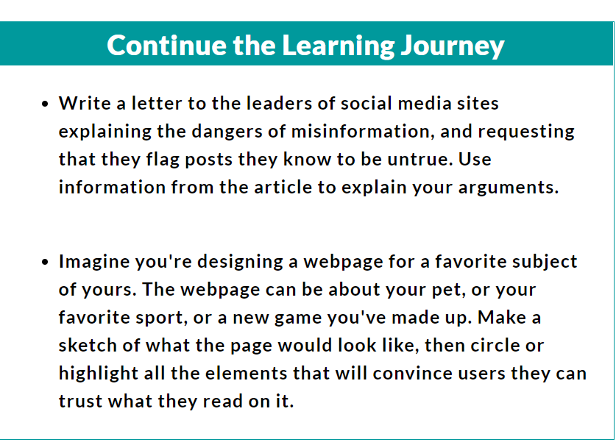
There are some articles that have math questions on the bottom instead of a writing prompt. Give me a summary of what the article was about instead.
Don’t forget to put the title of the article before you send me the document.

